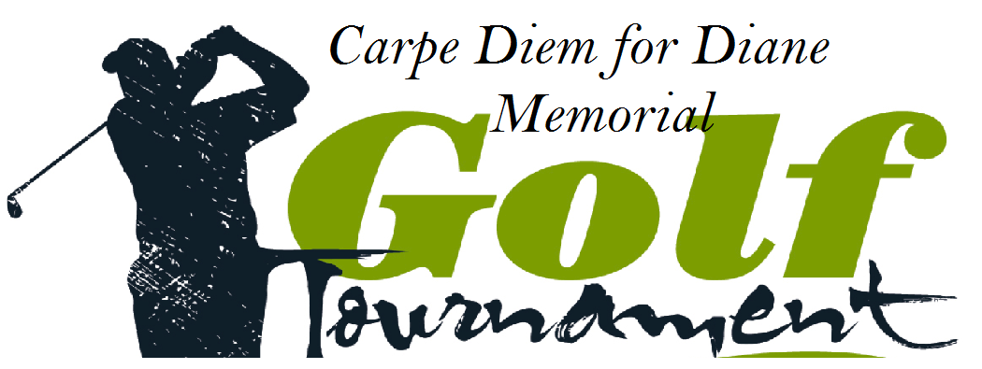

Thursday, May 22nd 2025
Candia Woods Golf Links – Candia, NH

SILENT AUCTION & RAFFLE DONATION FORM

Please complete this form and mail or e-mail to:
Amanda Ferdinando
c/o Carpe Diem for Diane
112 English Range Road
Derry, NH 03038
E-mail: aferd23@gmail.com
Website: www.carpediemfordiane.org

Donor Name: _____________________________________________
Organization Name: ________________________________________
Mailing Address: __________________________________________
________________________________________________________
Phone: __________________________________________________
E-mail: __________________________________________________

Please provide a brief description of the item you are donating: ___________________________________________________________________________ ___________________________________________________________________________ ___________________________________________________________________________ ___________________________________________________________________________ ___________________________________________________________________________ ___________________________________________________________________________ ___________________________________________________________________________

Please provide an approximate retail value: $___________________

We appreciate your Support! Thank you!

All money raised will be donated to local charities near and dear to Diane’s heart.
In loving memory of Diane Park Whatmough (formerly Ferdinando)
11/24/61 – 8/19/14

